Github  For Qlik Cloud mobile mashup  - Setup Instructions | 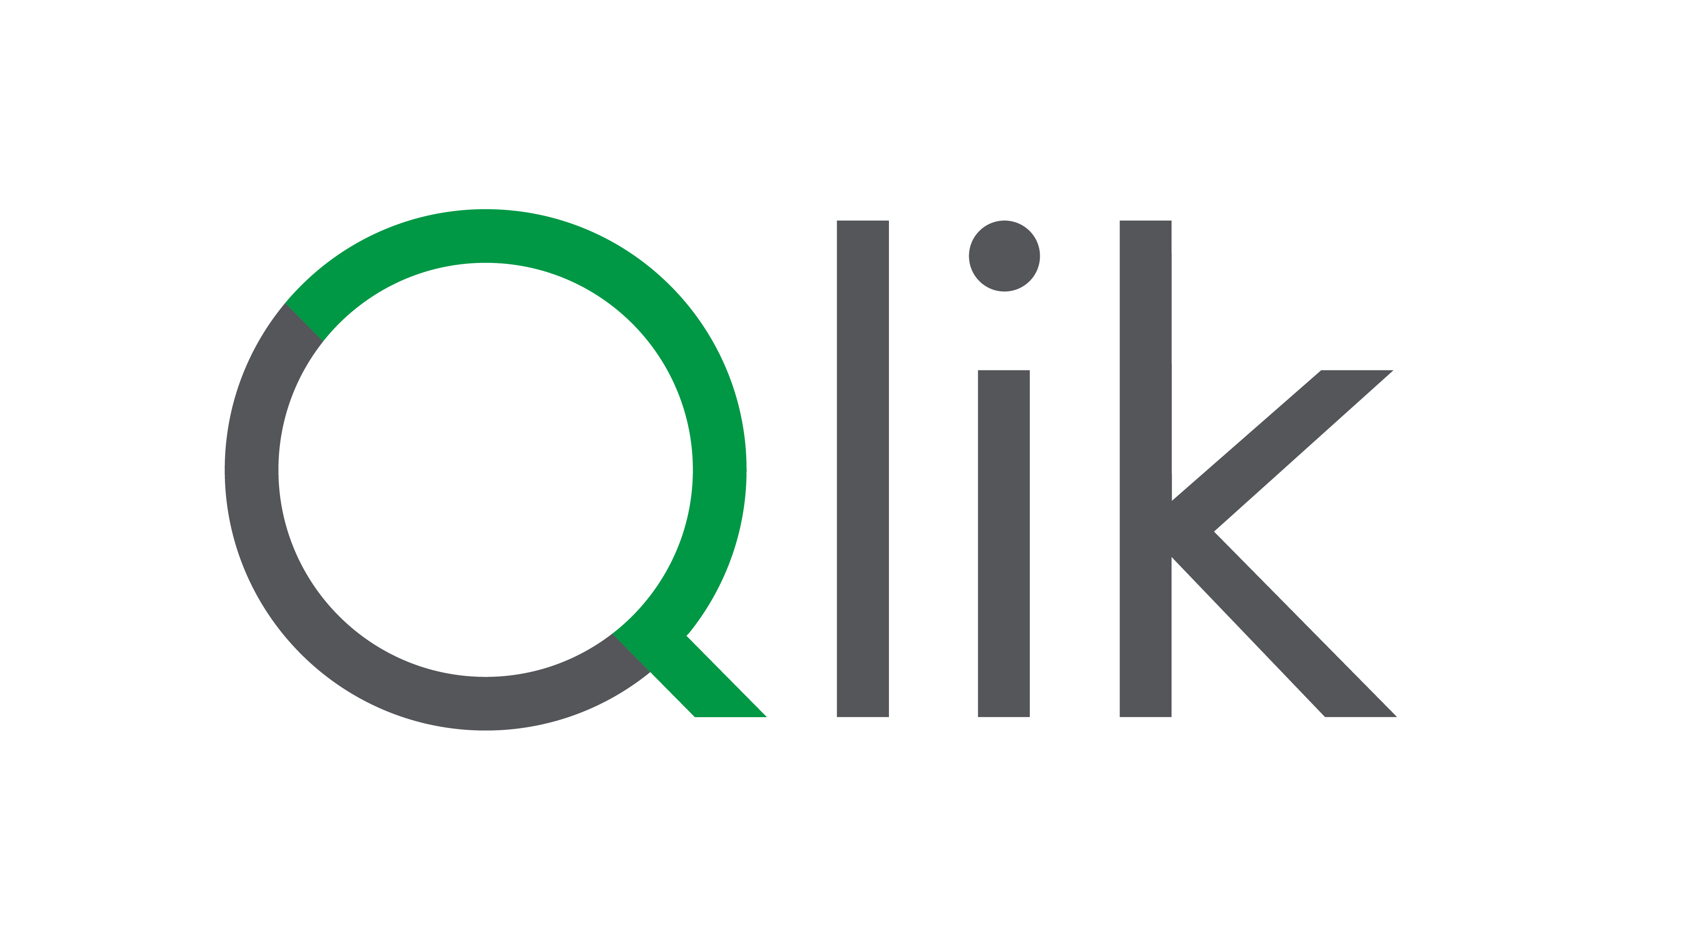
Using Github is an excellent option to publish your mashups when you want to easily share the content with general access. Many companies use this approach to publish html content.
We will focus on the use case of publishing mashups for Qlik Cloud and how it gets linked with your QC Tenant.

Reuse your current Github account
You just need an github repository to allocate your mashup. So if you already have a github account it’s gonna be useful.
In case you never signed up to github and create a repository, here you have some instructions:
- Github, how to start
- Repositories pricing, again it’s gonna be free, you won’t need to add any credit card to start

Already have an Github Account? Let’s continue…
Repository setup
Most of the cases you will share the content, for demos, with customers, with other colleagues,…
This is the way to make everything available for public access (keep in mind only the access to the index.html will be public, you’ll decide if you want anonymous access to the data or OAuth authentication).
Try it: Once logged in github, just click on create a new repository
- Click on the icon 
- Add a description and ‘Chose visibility’ as Public
The rest of options are optional.
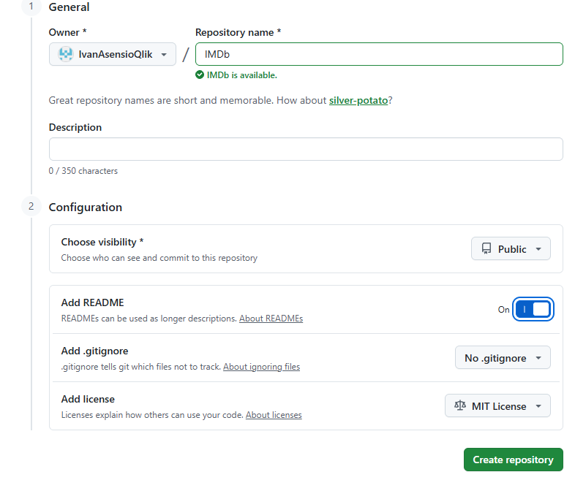
- Click on ‘Create repository’

Upload and publish the mashup objects
The minimum elements you need is just a single index.html file, that can be generated with the Qlik Cloud Mashup Builder.
But to be honest, you’ll probably want to have there some stuff like, images, videos, icons,…

Try it: This is an example of mashup allocated in Github, it’s composed by 4 objects
- ‘Index.html’, this is the minimum required, the mashup with html and js code inside
- ‘favicon.ico’, this is optional but useful, it’s the icon that appears in your browser when you access the mashup
- ‘img’, also optional, a folder with all your images, logos, videos and other visual content you will show in your mashup to improve the look & feel
- In case you use an authenticated access, you’ll need to add another object, the oauth-callback.html file
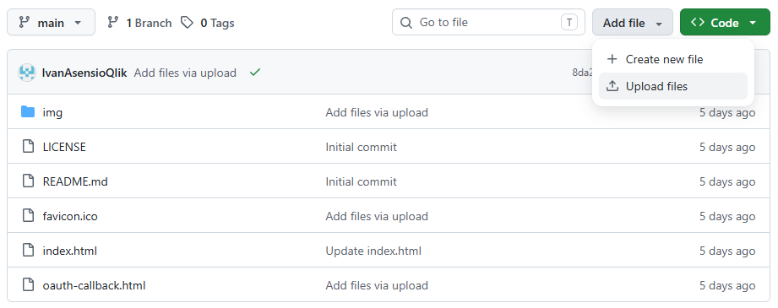
Try it: To make all objects public
- Select the option Setting in the top bar menu 
- Select the option Pages in the left menu

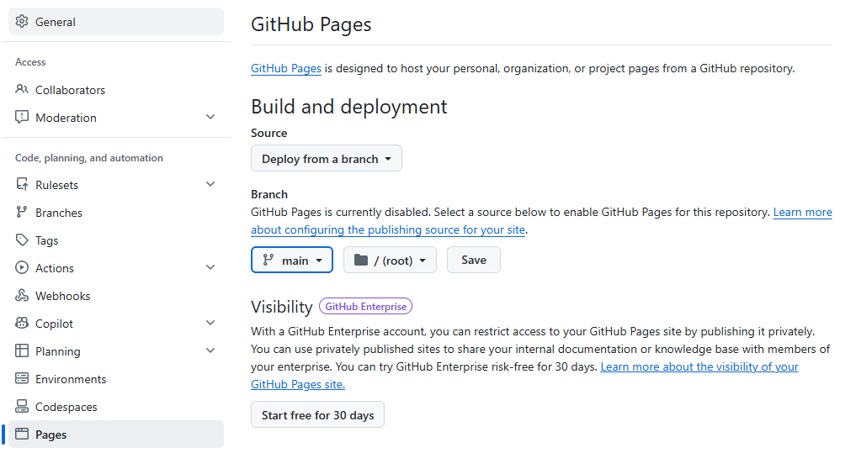
- In Branch chose ‘main’
- Click Save
- Put a sight on the option Custom domain, you can change it, but by default it will generate new link to your content, accountname .github.io

In github pages the access to content does not required the index.html in the url.
It could be just something like this: https://accountname.github.io/repositoryname/
It assumes the mashup is a file called index.html, and it’s not needed to add it to the URL.

How to connect this environment with your Qlik Cloud tenant:
- In case you set up it for Anonymous Access, just share this link with anyone that want to test. Get the URL mentioned URL to be used in Qlik Cloud when configuring the oauth ClientId, in this case:
  - https://accountname.github.io/repositoryname/ the link you want to share with your colleagues to allow them using the mashup
  - https://ivanasensioqlik.github.io this is the element you will type in Qlik Cloud admin console to set up the oauth ClientId as Allowed origin
- If the access is authenticated, the user will may be prompted to sign on (mashup builder will cause a prompt for authentication, if you want to change that for SSO please review the documentation about auth techniques for Qlik Embed)
  - https://accountname.github.io/repositoryname/ is the link you want to share with your colleagues to allow them using the mashup
  - https://accountname.github.io this is the element you will type in Qlik Cloud admin console to set up the oauth ClientId as Allowed origin
  - https://accountname.github.io/repositoryname/oauth-callback.html is the element you need to type in the oauth Client Id in Qlik Cloud as Redirect URL

